Example 3 - UAI 324 / 655 (advanced)

Exam – practical part – summer 2024/2025

Name of student
Date
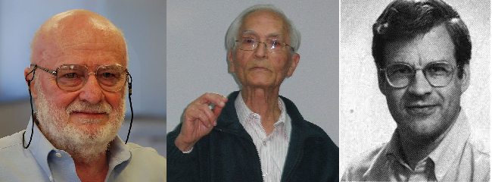

Create the program, which will compress and decompress the given string. The string is in github
https://github.com/MartaVohnoutovaBukovec/IOS-655-Python-a-Bash/blob/master/text_to_encrypt.txt
Put it into clipboard and put it in your program named exam2025_UAI324_LZW_your_name.py
Follow EXACTLY the two flowchart diagrams and the outputs will be
- output_list (in compression)
- output_string (in decompression), which must be identical to text_to_encrypt.txt
- your program
Note: flowcharts are also available on github

IOS-655-Python-a-Bash/lzw1.png at master · MartaVohnoutovaBukovec/IOS-655-Python-a-Bash
and
IOS-655-Python-a-Bash/lzw2.png at master · MartaVohnoutovaBukovec/IOS-655-Python-a-Bash

Second Old cipher

Compress
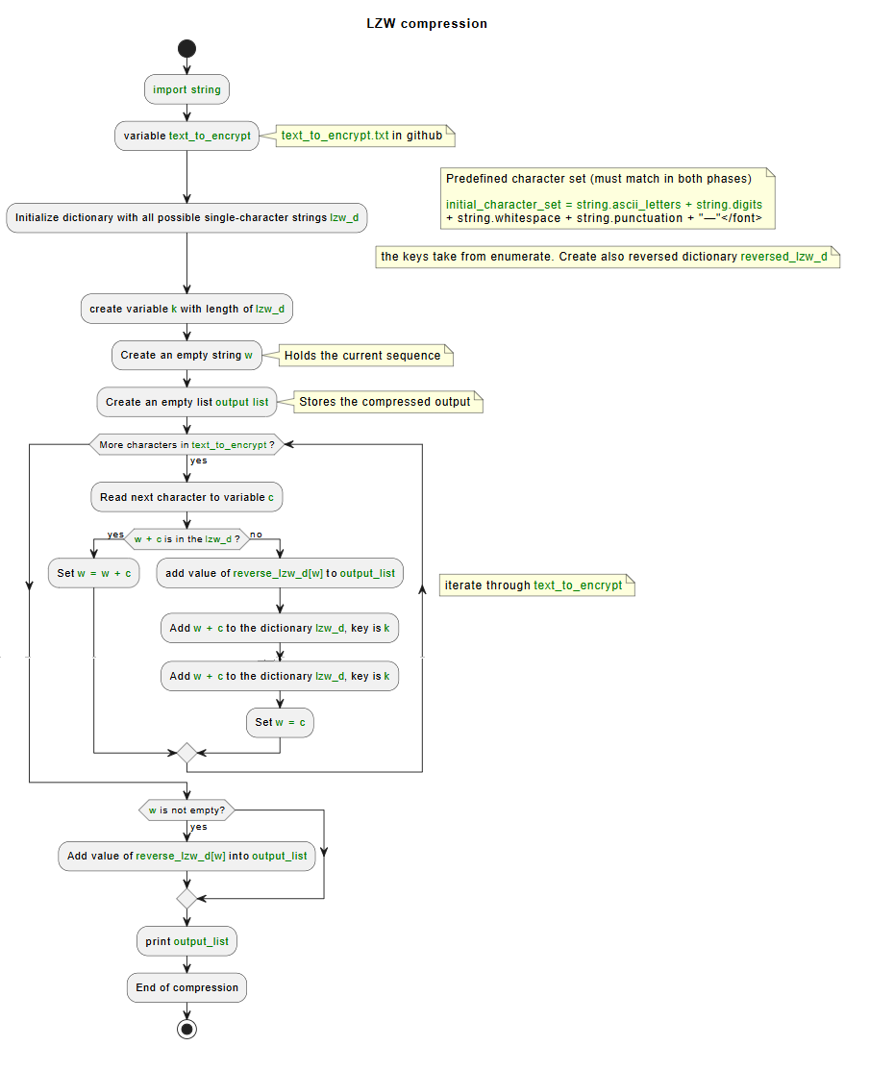

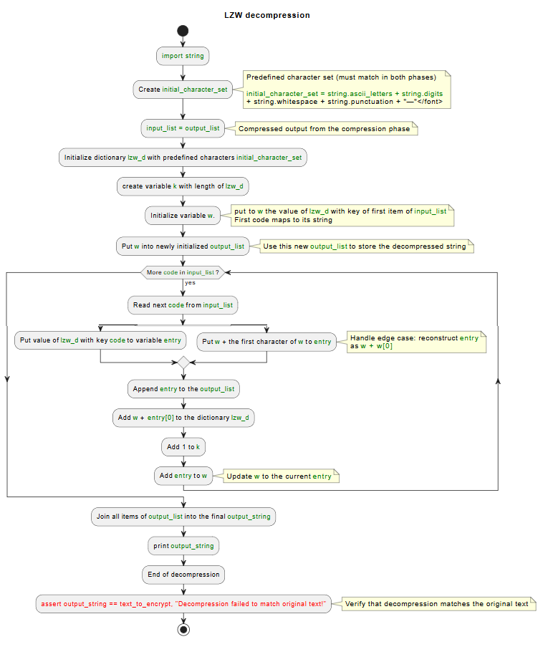
Decompress

The program:

